Start here: <http://www.venturausd.org/>

Click on the Parents link:



Click on Q Parent Connection in Helpful Links:

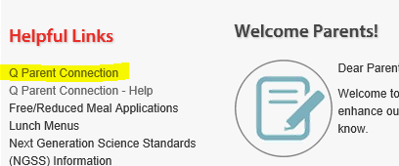

They can click on the FAQ’s in the top right hand corner:

